Banking Customer Churn - Prediction

# **Vinay Nagaraj DSC680 - T302 Applied Data Science (2217-1) https://vinaynagaraj88.github.io/DataScience_Portfolio/**

# 10 Questions & Answers

1. What's the % of Customer Churn? – Out of 10000 records, 2,037 of them are data related to customer who quit the bank.

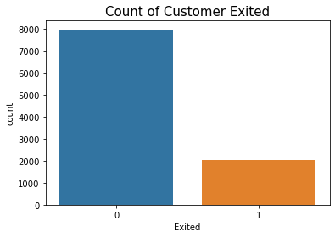

1. How does Gender impact customer churn? – Female customer tends to exit the bank more.

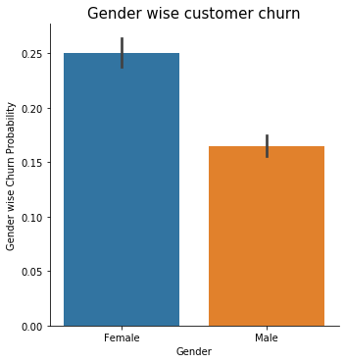

1. Which country has the highest Customer Churn? – Germany

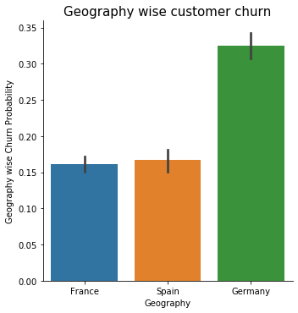

1. Does owning a Credit card with the bank have any affect? – Yes, Customers with no credit card tend to exit the bank more.

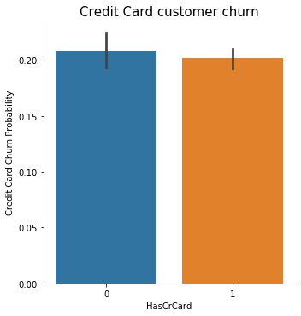

1. What's the distribution of Ages? – People with Ages between 30 to 40 has the highest probability of staying and Ages between 45 to 55 has the highest probability of leaving.

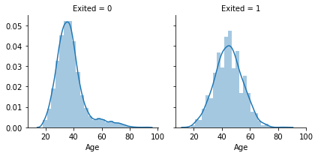

1. Activity of the customer with the bank important? Inactive customers tend to exit the bank more.

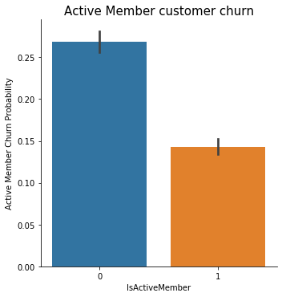

1. Products contribution to customer churn? - The ratio of exited cases with 3 or more products definitely higher than under 2 products

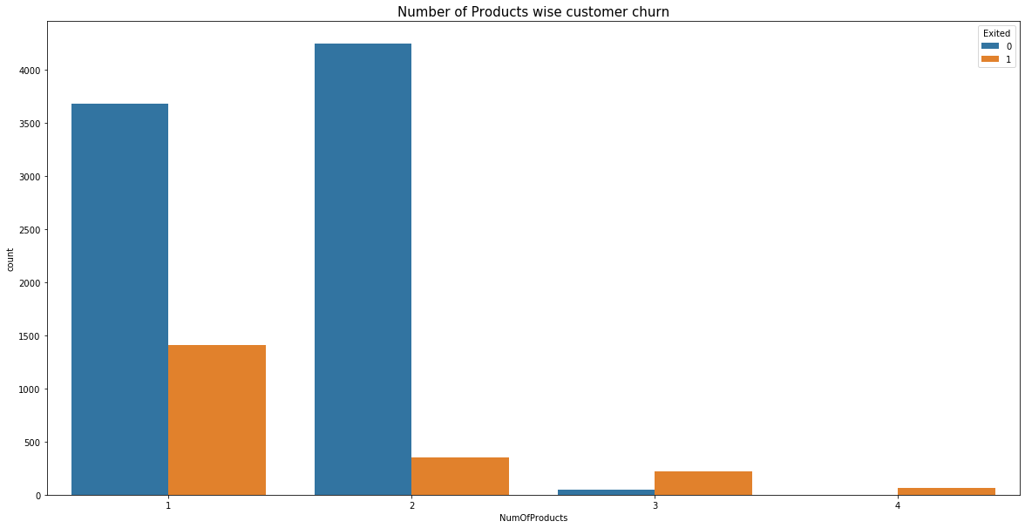

1. Which are the important features which can predict employee attrition? – ‘Age’ is the most important feature per SelectKBest technique.

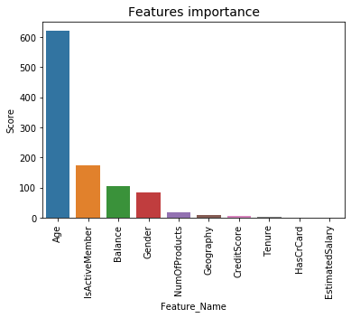

1. Which are the best suited classification models to predict employee attrition? - Random forest model has fewer false positives than other models making it a better model and will correctly predict if the Customer will quit the bank or not 86.1% of the time.
2. What is the accuracy scores of a few popular classification models? – See the chart below. Based on the roc_auc values for all the 7 models we compared, RandomForestClassifier, SVC(Support Vector Classifier) and GaussianNB (Gaussian Naive Bayes) had the better scores.

